# Do Humans Maintain a Representation of the Air Drag in their Environment?

Borja Aguado¹˚, Björn Jörges²˚, Joan López-Moliner¹*

¹ Vision and Control of Action (VISCA) group, Department of Cognition, Development and Psychology of Education, Institut de Neurociències, Universitat de Barcelona, Ps. Vall d'Hebron 171, 08035 Barcelona, Catalonia, Spain.

² Center for Vision Research, York University, 4700 Keele Street, Toronto, ON M3J 1P3, Canada

˚ These authors contributed equally to this work.

*Corresponding Author (j.lopezmoliner@ub.edu)

## Abstract

Humans represent and use an array of physical properties of their environment, from gravity, over the mass and size of known objects to regularities of lighting conditions. To time interceptive responses for flying targets accurately, it would be beneficial for humans to also maintain a representation of air drag. In this study, we test two hypotheses: do humans use air drag to extrapolate motion? And do humans represent the air drag-related characteristics of known objects separately? To test these hypotheses, we presented participants with parabolic trajectories in the fronto-parallel plane. The ball disappeared and subjects were asked to indicate by button press when the ball returned to its original height which was marked by an elongated table. Furthermore, they were asked to indicate where the ball hit the table. We manipulated presence or absence of air drag during the visible part of the trajectory, ball size (tennis ball size or basketball size), their texture (tennis ball or basketball texture) and initial horizontal and vertical velocities. Regarding our first hypothesis, we found some evidence that humans rely on a representation of air drag. Furthermore, we found strong evidence that expectations about air drag-related motion behavior is influenced both by the size and the texture of the target. Finally, in an exploratory analysis, we confirmed that a previously proposed relationship between perceptual biases and discrimination thresholds might also hold true for more ecological timing and spatial judgment tasks.

## Introduction

The importance of ecologically valid stimuli for the study of interceptive actions is self-evident. Nonetheless, many studies neglect air drag when simulating stimuli in virtual reality. While this can facilitate some aspects of setup and analysis, it could lead to systematic errors in results if people assume air friction. There is evidence that humans consider and use different physical properties of their environment, such as the size of known objects (Hosking & Crassini, 2010; López-Moliner, Field, & Wann, 2007), their mass (Neupärtl, Tatai, & Rothkopf, 2020), density (Peters, Ma, & Shams, 2016), gravity (Bosco et al., 2015; Gómez & López-Moliner, 2013; Indovina et al., 2005; Jörges & López-Moliner, 2019; Jörges & López-Moliner, 2017, 2020; La Scaleia, Zago, Moscatelli, Lacquaniti, & Viviani, 2014; Lacquaniti et al., 2013; McIntyre, Zago, & Berthoz, 2001; McIntyre, Zago, Berthoz, & Lacquaniti, 2003; Mijatovic, La Scaleia, Mercuri, Lacquaniti, & Zago, 2014; Senot, Zago, Lacquaniti, & McIntyre, 2005; Senot et al., 2012; Zago, La Scaleia, Miller, & Lacquaniti, 2011) or the direction of light (Adams, Graf, & Ernst, 2004) in their interactions with the environment. It is thus not unlikely that air drag is among these properties being used in complex environments.

Air drag is an umbrella term for different effects that act opposite to the motion direction of a moving object. Different types of air drag are parasitic drag, lift-induced drag and wave drag. Parasitic drag is the force that acts upon bodies that moves through liquids (including the air). Lift-induced drag occurs when a body redirects airflow, as for example wings do. Wave drag is present when objects move around the speed of sound, as well as at the borders between different liquids. For everyday interception tasks, parasitic drag is most relevant. It is computed as follows:

|  |  |
| --- | --- |
|  | [1] |

is the drag coefficient of the object; it is calculated based on the density of the surrounding fluid (1.225 kg/m³ at a temperature of 15° C in the case of air), the drag coefficient , which depends on the object shape, and the radius *r*. The drag force relates thus quadratically to velocity and diameter of the target: faster objects with a bigger cross-section are affected much more strongly by air drag than smaller, more slowly moving objects. For completeness sake, the so-called Magnus force should not be left unmentioned, which is responsible, for example, for topspin effects in ball sports like tennis. Magnus forces act upon objects that spin while moving through liquids and can drive a tennis ball downwards in an unexpected fashion. However, the current study neglects Magnus forces and focusses entirely on air drag.

Air drag can thus be envisioned as negative, dynamically developing acceleration acting opposite to the direction of motion of the target. As such, it is in two ways different from the other very common acceleration in our environment, gravity: First, the direction of the gravitational acceleration is always acting in the same direction, independently of object motion. Second, its force does not depend on the velocity of the target.

While ecological theories of perception posit that most tasks can be solved without extensive internal representation of the environment (see, e. g. Wilson & Golonka, 2013),­ computational models often rely on identifying to what extent we represent and make use of our knowledge about the world (Gómez & López-Moliner, 2013). The present study thus aims to investigate whether air drag is, like gravity, mass or density, among the physical properties of the environment represented by the brain. If this is the case, we expect systematic errors when no air drag is simulated, and an accurate performance when air drag is simulated (Hypothesis 1). If humans represent air drag, it stands to reason that they adapt their expectations to the object at hand, with regards to, for example, its size. We would thus expect predictions to be equally accurate for two objects with different sizes (Hypothesis 2). It furthermore stands to reason that humans integrate all available information to make interceptive actions as accurate as possible. For known objects, such as tennis balls or basketballs, the texture could represent such additional cues to be integrated with online visual information. We thus expect to observe systematic errors when the air drag acting upon a simulated object does not correspond to its appearance (e. g. a basketball-sized target with the texture of a tennis ball; Hypothesis 3).

## Methods

## Participants

We tested n = 20 participants (6 self-identified men and 14 self-identified women). They were between 19 and 44 years old and had all normal or corrected-to-normal vision. All of them were either colleagues from the department or Psychology students at University of Barcelona and could participate in research activities to acquire course credits. Informed consent was obtained. Data collection was conducted according to the guidelines of the Declaration of Helsinki, and the experiment was part of an ongoing project that was approved by the local ethics board.

Apparatus

We presented overlaid images on a back-projection screen (244 cm tall and 184 cm wide) with two Sony laser projectors (VPL-FHZ57). They provided a resolution of 1920 × 1080 pixels and a refresh rate of 85 Hz for each eye. Circular polarizing filters were used to provide stereoscopic images. Participants stood at 2 m distance centrally in front of the screen and used polarized glasses to achieve stereoscopic vision. The shown disparity was adapted to each participant’s interocular distance. Responses were given with a joystick.

Setup

­We presented participants with parabolic motion in the fronto-parallel plane in a rich 3D environment that provided cues about the distance to the target, at a simulated distance of 6m from the participant. The ball disappeared after reaching peak (between 55 % and 60 % of the full flight duration; the exact values was drawn randomly from a uniform distribution) and participants indicated by button press when the ball dropped back to the height it was launched from (indicated by a simulated table). Then, the ball reappeared in a random position drawn from a uniform distribution simulated point-of-impact on the table and participants used a joystick to move the ball, indicating the position where they thought the ball hit the table. The target had the texture of a tennis ball (texture) and the physical properties (size, mass, density, drag coefficient) of a tennis ball (Tennis ball, Congruent), the texture of a basketball and the physical properties of a basketball (Basketball, Congruent), the texture of a tennis ball and the physical properties of a basketball (Tennis ball, Incongruent) or the texture of a basketball and the physical properties of a tennis ball (Basketball, Incongruent). For the tennis ball, we simulated a radius of 0.033 m and a mass of 0.06 kg. For the basketball, we assumed 0.12 m radius and a mass of 0.12 kg. Since the drag coefficient for both tennis balls (, Chadwick & Haake, 2000) and basketballs (, see Okubo & Hubbard, 2010) are very similar due to their nearly identical shape, we chose an intermediate value of 0.535 for both. We simulated no spin and neglected Magnus forces. The ball could start with an initial horizontal velocity of 3.0 or 3.5 m/s. The initial vertical velocity was given such that the overall flight time (visible + invisible) was 1.0, 1.2 or 1.4 s for the Tennis Ball, Congruent, without air drag conditions and ranged between 4.9035 and 6.8649 m/s. We matched the initial vertical velocities for the other conditions, which lead to slight differences in overall flight duration (0.98 to 1.0 s; 1.17 to 1.2 s; 1.352 to 1.4 s) and horizontal length of the trajectory. The duration of the occluded part of the trajectory was 40 to 45 % of the overall flight time and ranged thus between 0.392 and 0.63 s.

In half of trials, the trajectory unfolded in the absence of air drag, that is the target’s x and y positions were given by the regular equations for parabolic motion:

|  |  |
| --- | --- |
|  | [2] |
|  | [3] |

is the *x* position in time; is the horizontal acceleration, which for motion with air drag is constant at 0 m/s²; *t* is the time that has passed since inception of the trial; refers to the horizontal velocity, which is constant without air drag; is the *y* position in time; is the vertical acceleration, which for motion without air drag is constant at earth gravity (-9.81 m/s²); and refers to the initial vertical velocity.

The other half of trials were simulated under the influence of air drag, where we compute acceleration and velocities dynamically on each frame according to the following equations:

|  |  |
| --- | --- |
|  | [4] |
|  | [5] |
|  | [6] |
|  | [7] |
|  | [8] |
|  | [9] |
|  | [10] |

, , , , and are *x* position, *y* position, horizontal velocity, vertical velocity, tangential velocity, horizontal acceleration and vertical acceleration in time, respectively; g is earth gravity (9.807 m/s²), is the drag force (see Equation 1) and *m* is the mass of the object (0.06 kg for the tennis ball and 0.6 kg for the basketball).

## 

Figure : A. Trajectories per initial horizontal velocity, time-to-contact and ball type in the context of a 2D image of the visual scene. The gold parts close to the peak illustrate the range during which the ball disappeared. B. Simulated horizontal acceleration over time. The flat line intercepting the y axis at y = 0 indicates acceleration under the “Air Drag: Absent” condition. C. Same as B, but for the vertical acceleration; again, the flat line interception the y axis at y = 9.807 indicates acceleration in the “Air Drag: Absent” condition. D. Simulated effective times-to-contact per time-to-contact. Different icon types denote whether the physical properties of the object corresponded to a Basket (circle) or Tennis (triangle) ball. Colors illustrate whether air drag was present (blue) or not (red). E. Same as D, but for the point of impact.

While longer flight durations would have led to greater differences between “Air Drag: Present” and “Air Drag: Absent”, it was important to provide as realistic an environment as possible, as it has been shown previously that humans only apply some of their knowledge about the world when the display is immersive enough (Zago et al., 2011). Temporally and spatially longer trajectories would have required us to simulate the targets at even greater distances, making virtual reality-related biases in distance perception (Messing & Durgin, 2005) more likely. For the sake of more ecologically valid circumstances, we thus opted for an intermediate distance and shorter presentation times. Figure 1 provides an oversight over different parameters of our stimuli.

Before commencing the main part of the experiment, each subject was asked to move around in the virtual environment using a joystick. This was done so that the participants could become familiar not only with the environment, but also with the actual size of the balls presented in this experiment. After giving them about half a minute to familiarize themselves with the experiment, they underwent 48 training trials (each condition combination once) in which the ball reappeared when they pressed the button used to time their response. This gave them spatial cues about their error and allowed them to attune to the task and the visual scene.

The Python program used to present the stimuli and collect the data has been uploaded on Open Science Foundation (<https://osf.io/8gxp7/>).

## Data Analysis Plan and Predictions

We first standardized responses times and spatial errors by adding them to the extrapolated duration or space and then dividing them by the extrapolated duration or space. This way, we achieve a standardized value that is comparable across the different times-to-contact, where 1 indicates perfect accuracy, values below one denote too early temporal responses or an undershoot and values above one denote too late temporal responses or an overshoot.

|  |  |
| --- | --- |
|  | [11] |
|  | [12] |

We then removed those trials as outliers where the spatial Error Ratio was smaller than 0.25 or greater than 4. Additionally, we remove those trials as outliers where the timing response was given earlier than 100 ms after the ball disappeared and larger than 3 seconds (in comparison to correct responses between 380 and 630 ms). We found that the lower bound for the timing response removed a significant portion of trials for two participants (18.5% for s02 and 14.5% for s04; see Complementary Figure 1) while the mean percentage of removed trials for the rest of the participants is 1.09% . Therefore, we concluded that these participants did not consistently follow task instructions and excluded them from further analyses. In a second step, we removed those trials where either of the absolute errors lay more than 1.5 times the interquartile distance above the upper quartile for the regarding participant and condition or below the lower quartile. this led to a loss of another 1067 trials, or 6.17% of the remaining trials. We then proceeded to test our hypotheses with a combination of Linear Mixed Modelling (Bates, Mächler, Bolker, & Walker, 2015) and Bayesian Linear Mixed Modelling (Bürkner, 2018; Stan Development Team, 2016). Linear Mixed Modelling allows to estimate intercepts and regression coefficients across the whole population (“fixed effects”) or separately for sub-groups of the population (“random effects”). This allows us to separate between variability in responses due to the effect in question, and variability due to other sources, e. g. idiosyncrasies in the mean response criterion of each participant. Bayesian Linear Mixed Modelling extends this framework by estimating whole distributions for each fixed and random effect. It furthermore provides a convenient way to quantify the support data lend *in favor of* a Null Hypothesis when the Null Hypothesis can’t be rejected. Bayesian analyses furthermore allow to directly contrast two competing hypotheses and quantify to which extent the data confirm one hypothesis over another. This will play an important role for Hypothesis 1 (see below). It furthermore enables the application of priors; we, however, will not make use of this feature in the present paper, and rely on a very shallow default prior.

We test each hypothesis both temporally and spatially. For **Hypothesis 1**, we expect humans to use their internalized knowledge of air drag in their habitual environment to predict object motion. Therefore, performance should be accurate for those trials where air drag is simulated and systematic errors should be observed when the trajectory unfolds without the influence of air drag. In the temporal task, participants are expected to respond too late when no air drag is simulated in the visible part of the trajectory because air drag would slow the target down on its way from peak back to the initial level. (*Prediction 1a*). In the spatial task, participants should expect the ball to be slowed down by air drag, so we predict an undershoot in participant responses (i.e., they place the object too far to the left; *Prediction 1b*). The predictions are depicted in Figure 1A.

We first test whether there are any differences between both conditions via Linear Mixed Modelling, and then establish 95% confidence interval for both “Air Drag: Present” and “Air Drag: Absent” with a bootstrapping method to verify whether either of them does not include 0. If neither or both confidence intervals contain 0, i.e., if we can reject the Null Hypothesis for both conditions or can’t reject it for either, we use Bayesian Linear Mixed Modelling to determine in which of both conditions accuracy is higher relative to the other.

For **Hypothesis 2**, we expect that temporal and spatial errors are comparable for targets of tennis ball size and targets of basketball size in the “Air Drag: Present” condition, indicating that participants adapt their predictions to the target sizes and respond accurately in both conditions. In the “Air Drag: Absent” condition, in turn, we should see differences if humans take the size into account when extrapolating motion. When participants extrapolate motion according to a correct physical model of air drag, we expect them to respond earlier for smaller targets and later for bigger targets. For the spatial task, we expect participants to place the point of impact further to the left for bigger targets than for smaller targets. Figure 1B shows the predictions.

We test this hypothesis with Linear Mixed Modelling (*Predictions 2a* and *2b* for the temporal and the spatial errors, respectively) and expect a significant interaction between Size and Air Drag condition

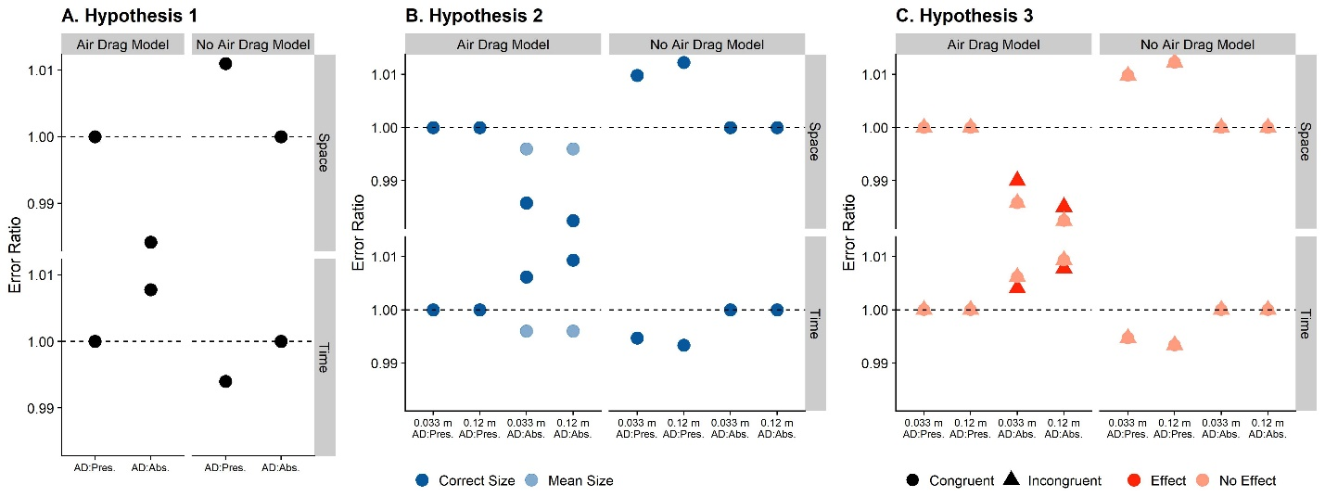

Figure 3: Predictions for the different conditions and hypotheses, assuming that humans extrapolate motion with an air drag assumption (left column of panels) and without an air drag assumption (right column of panels), and for both modalities, Space (upper row of panels) and Time (lower row of panels). A. Predictions separated by whether on any given trial air drag was simulated or not (x axis). B. Predictions separated by “Air Drag: Present” versus “Air Drag: Absent” and the presented target size (x axis), as well as whether participants used the correct size for each condition or an average size (r = 0.0765 m) across conditions, independently of the presented target size (color-coded dark blue for Correct Size, and light blue for mean size). C. Predictions separated by “Air Drag: Present” versus “Air Drag: Absent” and the presented target size (x axis). Predictions are further divided up by whether ball size and ball texture were Congruent (circle) or Incongruent (triangle), and whether participants’ perception was unduly influenced by the texture (dark red for “Effect” and light red for “No Effect”).

**Hypothesis 3** is contingent on Hypothesis 2. If we find support for Hypothesis 2, we could expect that familiarity with an object affects how participants extrapolate motion. If humans integrate online visual information about the target (e.g., visual angle or binocular cues) with prior information (e. g. texture cues that evoke a known object), we expect responses to differ slightly between trials where visual online information and texture are congruent versus trials when they are incongruent. That is, if humans integrate texture cues about the object with online visual cues, we expect systematic errors when the two types of information are incongruent. For targets with tennis ball texture, but basketball size and mass (Tennis, Incongruent), participants should respond slightly later than for the target with basketball texture and basketball size because they would integrate online visual cues about its (bigger) size with texture cues that indicate a smaller size, which would lead them to judge the target to be smaller than it actually is, and thus affected slightly less by air drag. For the target with basketball texture, but tennis ball size and mass, participant should respond slightly earlier than for the target with tennis ball texture and tennis ball size (*Prediction 3a*) In the spatial domain, we expect participants to undershoot (i.e., they perceive the point of impact too far to the left) for the “Basketball, Incongruent” target with regards to the “Tennis Ball, Congruent”, and an overshoot (i.e., they perceive the point of impact too far to the right) for the “Tennis Ball, Incongruent” target with regards to the “Basketball, Congruent target” (*Prediction 3b*).

All data, as well as the R script used to analyze the data, can be found on GitHub (<https://github.com/b-jorges/AirDrag>).

## Results

In the following, we report the confirmatory analyses to test our main **Hypotheses 1, 2 and 3** via *Predictions 1a, 1b, 2a, 2b, 3a* and *3b*.

### Hypothesis 1: Representation of Air Drag

First, we test the timing responses (*Prediction 1a*). We expect high accuracy for “Air Drag: Present” and too late responses for “Air Drag: Absent”. Figure 2A displays the distribution of responses for the timing task. To test our hypothesis, we use Linear Mixed Modelling, implemented in the package lme4 (Bates et al., 2015; Bürkner, 2018) for R. We fit a Mixed Model with “Air Drag” as fixed effect (a binary categorical variable with the values “Present” and “Absent”) and random intercepts per participant to explain timing error ratio. Please note that the skew of the displayed distribution (Figure 2A) disappears when looking at the data at the participant level, as you can see in Complementary Figure 1; the condition of normality is thus not violated under a Linear Mixed Model. In lme4 syntax, the Mixed Model is specified as:

|  |  |
| --- | --- |
|  | [13] |

We compared this Test Model to a Null Model that doesn’t contain the variable of interest:

|  |  |
| --- | --- |
|  | [14] |

A Likelihood Ratio Test showed that the Test Model is significantly better than the Null Model (p = 0.005). The intercept for the Test Model is 1.007 (SE = 0.106) and the intercept for the Null Model is 1.015 (SE = 0.106). The regression coefficient for the fixed effect “Air Drag: Absent” is 0.016 (SE = 0.005), indicating that responses occurred proportionally later in this condition. Humans thus use the same internalized knowledge to extrapolate motion independently of whether air drag was presented during the visible part of the trajectory or not. This result alone is, however, agnostic to whether humans consistently use air drag or consistently don’t use air drag for motion extrapolation, as in both cases, responses would occur later in the “Air Drag: Absent” condition than in the “Air Drag: Present” condition.

The tiebreaker to this question is which of the conditions is more accurate (i.e., an error ratio closer to 1). In our frequentist framework, we can ascertain if the intercept of the Mixed Model differs significantly from one in either of the conditions. To this end, we establish a Mixed Model for each condition separately where we coerce the Intercept to be one:

|  |  |
| --- | --- |
|  | [15] |

We compare this Test Model to a Null Model where we allow the Intercept to vary:

|  |  |
| --- | --- |
|  | [16] |

For neither the two conditions (“Air Drag: Present” and “Air Drag: Absent”), the Test Model is significantly better than the Null Model (p = 0.945) and (p = 0.824) respectively. Then we computed the confidence interval (95% confidence interval) for the intercept of the Null model using a bootstrap procedure for both conditions “Air Drag: Present” [0.795: 1.195] and “Air Drag: Absent” [0.817; 1.207]. Both confidence intervals include 1, that is, we cannot reject the Null Hypothesis for either of the two conditions.

Not being able to *reject* the Null Hypothesis does not equal *support for* the Null Hypothesis. Unlike Null Hypothesis Testing, Bayesian analyses allow to quantify to what extent the data support the Null Hypothesis, that is, in our case, that responses are accurate for either “Air Drag: Present” or “Air Drag: Absent”. We therefore use Bayesian Linear Mixed Modelling, implemented in the packages brms (Bürkner, 2018) and rstan (Stan Development Team, 2016) for R (R Core Team, 2017). Brms allows the use of a flat prior, in which case the posterior corresponds to the likelihood. We choose this option because our objective is not to use prior information, but rather to quantify support for a null hypothesis. Brms uses the same syntax as lme4; we thus fit the following model:

|  |  |
| --- | --- |
|  | [17] |

Brms does not require testing of a Test Model against a Null Model. Rather, we can use the hypothesis() function to directly contrast two hypotheses. In our case, the hypothesis is whether performance for “Air Drag: Present” (i.e., the intercept) differs more from 1 than performance for “Air Drag: Absent” (i.e., the intercept plus the regression coefficient for “Air Drag: Absent”). This test returns a posterior probability of 0.49, which corresponds to an Evidence Ratio of 0.98 (“Air Drag: Absent” is 0.0005 further away from 1, SE = 0.014, 95 % CI = [-0.02; 0.02]); that is, the data support neither of the two hypotheses over the other.

For the spatial task (*Prediction 1b*), we expect high accuracy for “Air Drag: Present” and an undershoot for “Air Drag: Absent”. Figure 2B visualizes the distribution of responses for each condition. We follow the same procedure as for the timing response and fit the following Test Model:

|  |  |
| --- | --- |
|  | [17] |

We then compare it to the following Null Model:

|  |  |
| --- | --- |
|  | [18] |

By means of a Likelihood Ratio Test, we found that the Test Model is significantly better than the Null Model (p < 0.001). The intercept for the Test Model is 0.9106 (SE = 0.0445) and the intercept for the Null Model is 0.901 (SE = 0.0445). The regression coefficient for “Air Drag: Absent” is -0.0197 (SE = 0.002). We again test whether the intercepts differ significant from 1 in either condition. We find that the intercept does not differ for the “Air Drag: Present” condition (p = 0.051), while it does differ significantly for the “Air Drag: Absent” condition ( = 0.019). Then we computed the confidence interval (95% confidence interval) for the intercept of the Null model using a bootstrap procedure for both conditions “Air Drag: Present” [0.821;1.008] and “Air Drag: Absent” [0.802; 0.987]. The confidence interval for “Air Drag: Present” includes 1, whereas its counterpart for “Air Drag: Absent” not.

However, considering that the intercept for “Air Drag: Absent” is only marginally different from 1, we again perform the Bayesian analysis outlined above with the following model:

|  |  |
| --- | --- |
|  | [20] |

Here, we find a Posterior Probability of 0.97, corresponding to an Evidence Ratio of 35.04, in favor of “Air Drag: Present” eliciting more accurate responses (“Air Drag: Present” is -0.02 closer to 1, SE = 0.007, 95 % CI = [-0.027; -0.017]). This represents moderate-to-strong evidence that humans use internalized knowledge of Air Drag to extrapolate positional information.

Overall, our data represents strong evidence that humans do not switch between an air drag-based model and a non-air drag-based model for motion extrapolation, but rather use the same model independently of what is presented to them. The timing task furthermore provides no evidence to distinguish between an air drag-dependent and an air drag-independent model, while the spatial task provides relatively strong evidence in favor of an air drag-based model.

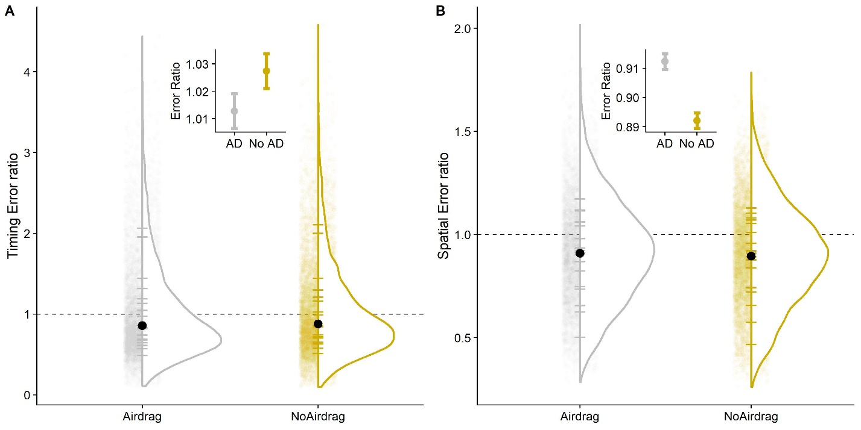

Figure : Distribution of responses error ratios for Air drag and No Air drag. Each small transparent dot represents one trial. The fat black dot is the median across all conditions and participant. The short solid horizontal lines represent the median performance for each participant. The dotted line indicates a timing error ratio of 1, that is perfect accuracy. In the insets, we display the mean error of each condition (dots); the error bars indicate +/- 1 standard error. A. Timing task. B. Spatial task.

### Hypothesis 2: Target size and air drag-related extrapolation

We furthermore hypothesized that humans might extrapolate motion taking into account that air drag affects objects of different physical sizes differently. Figure 3 visualizes the response distribution and mean errors for each target size and task. To test this hypothesis, we use Linear Mixed Modelling to fit the following models:

|  |  |
| --- | --- |
|  | [19] |
|  | [20] |

And compare them again Null Models without Ball Size as fixed effect:

|  |  |
| --- | --- |
|  | [21] |
|  | [22] |

We tested the Test Models against the Null Models with a Likelihood Ratio Test and found the variable “Ball Size” did not improve the model fit significantly for the temporal task (p = 0.283). The intercept for the Test Model is 1.008 (SE = 0.106) and the intercept for the Null Model is 1.005 (SE = 0.106). The regression coefficient for “Ball Size: 0.12 m” is -0.002 (SE = 0.008); for “Air Drag: Absent” it is 0.01 (SE = 0.008; and for their interaction it is 0.012 (SE = 0.011) The absence of an appreciable difference alone, however, does not provide strong evidence that humans adapt their predictions to the size of the object at hand, as differences in the temporal domain are quite small between “Air Drag: Absent” and “Air Drag: Present” (see Figure 1D).

For the spatial task, however, the physical differences are more pronounced (see Figure 1E). Finding no difference between object sizes for the “Air Drag: Present” condition and an undershoot for big targets in comparison to small targets would thus entail some support for the idea that humans take into account an object’s size to judge the effect of air drag on its trajectory. The interaction between improved the model fit significantly (p < 0.001). The intercept for the Test Model is 0.946 (SE = 0.045) and the intercept for the Null Model is 0.899 (SE = 0.044). The regression coefficient for “Ball Size: 0.12 m” is 0.032 (SE = 0.004); for “Air Drag: Absent” it is -0.01 (SE = 0.004), and -0.017 (SE = 0.005) for the interaction. That is, the difference between the sizes is smaller when no airdrag was simulated. Big targets were thus associated with an overshoot with regards to small targets for both air drag conditions, although less so for “Air Drag: Absent”. While there seems to be a general size-based mis-extrapolation that somewhat masks effect, the interaction term, which is relevant to our Hypothesis, is significantly different from zero and has the expected sign. Please note that an internal model excluding air drag would lead to the same results for the interaction term (see Figure XXXXX), with the difference being in the intercepts. Above, we have shown that our data favor the notion that humans use an air drag-based internal model to extrapolate motion. Under the assumption that this is true, our results for Hypothesis 2 show that, rather than using a mean air drag value across targets, humans account for how air drag affects objects of different sizes differentially.

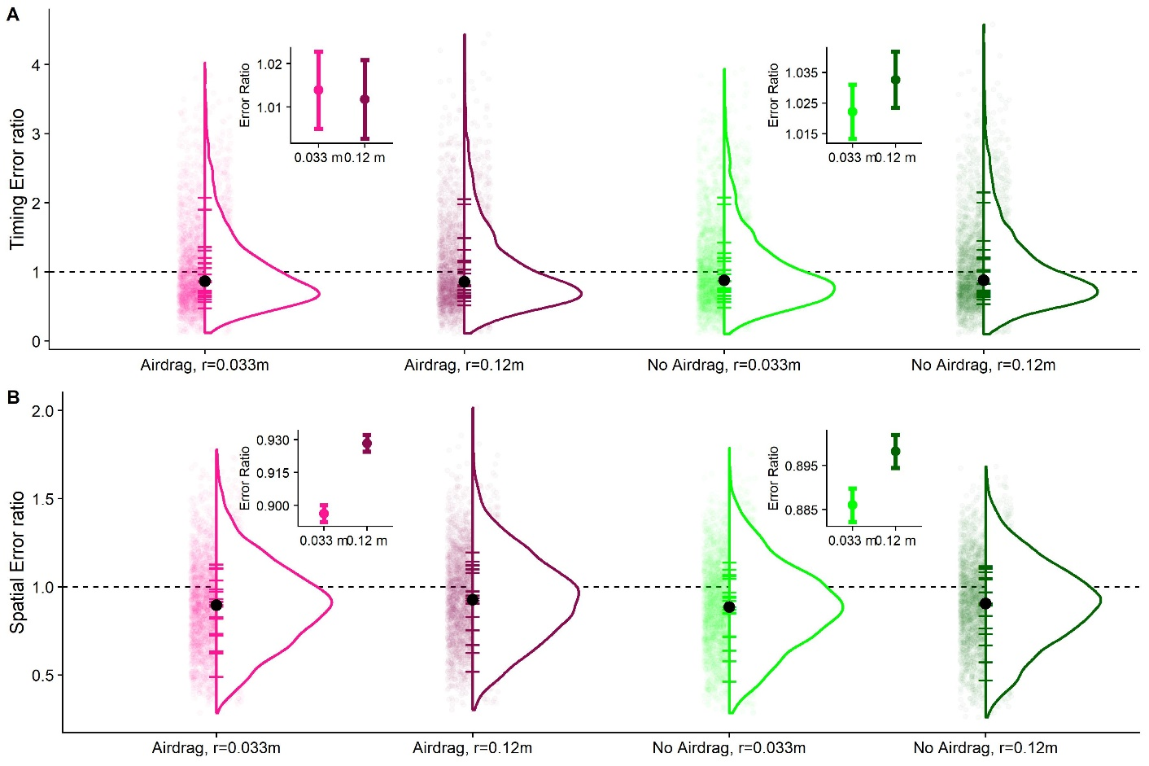

Figure : Distributions of error rations for targets of 0.033 m and 0.12 m diameter. Each small transparent dot represents the error ratio of one trial and participant. The fat black dot is the median across all conditions and participant. The short solid horizontal lines represent the median performance for each participant. The dotted line indicates a timing error ratio of 1, that is perfect accuracy. In the insets, we display the mean error of each condition (dots); the error bars indicate +/- 1 standard error. A. Timing task. B. Spatial task.

### Hypothesis 3: The influence of context information on motion extrapolation

While it is unlikely to find any effect of familiarity (Hypothesis 3) when we could not find an effect of size (Hypothesis 2), this failure to detect an effect of size could be due to confounding factors. We therefore conduct the analysis planned for Hypothesis 3 nonetheless. As before, we use Linear Mixed Modelling. For each task, we compare a test model that includes “Ball Size” (as above) and “Texture” (a binary variable with the values “Basketball” and “Tennis ball”) and their interaction as fixed effects.

|  |  |
| --- | --- |
|  | [23] |
|  | [24] |

to a null model that includes only the main effects.

|  |  |
| --- | --- |
|  | [25] |
|  | [26] |

In line with the results for Hypothesis 2, we find that neither of the test models is significantly better than the respective null model ( p = 0.91 for the timing, and p = 0.50 for the spatial responses). In Figure 4, we visualize the response distributions for each combination of target size and texture.

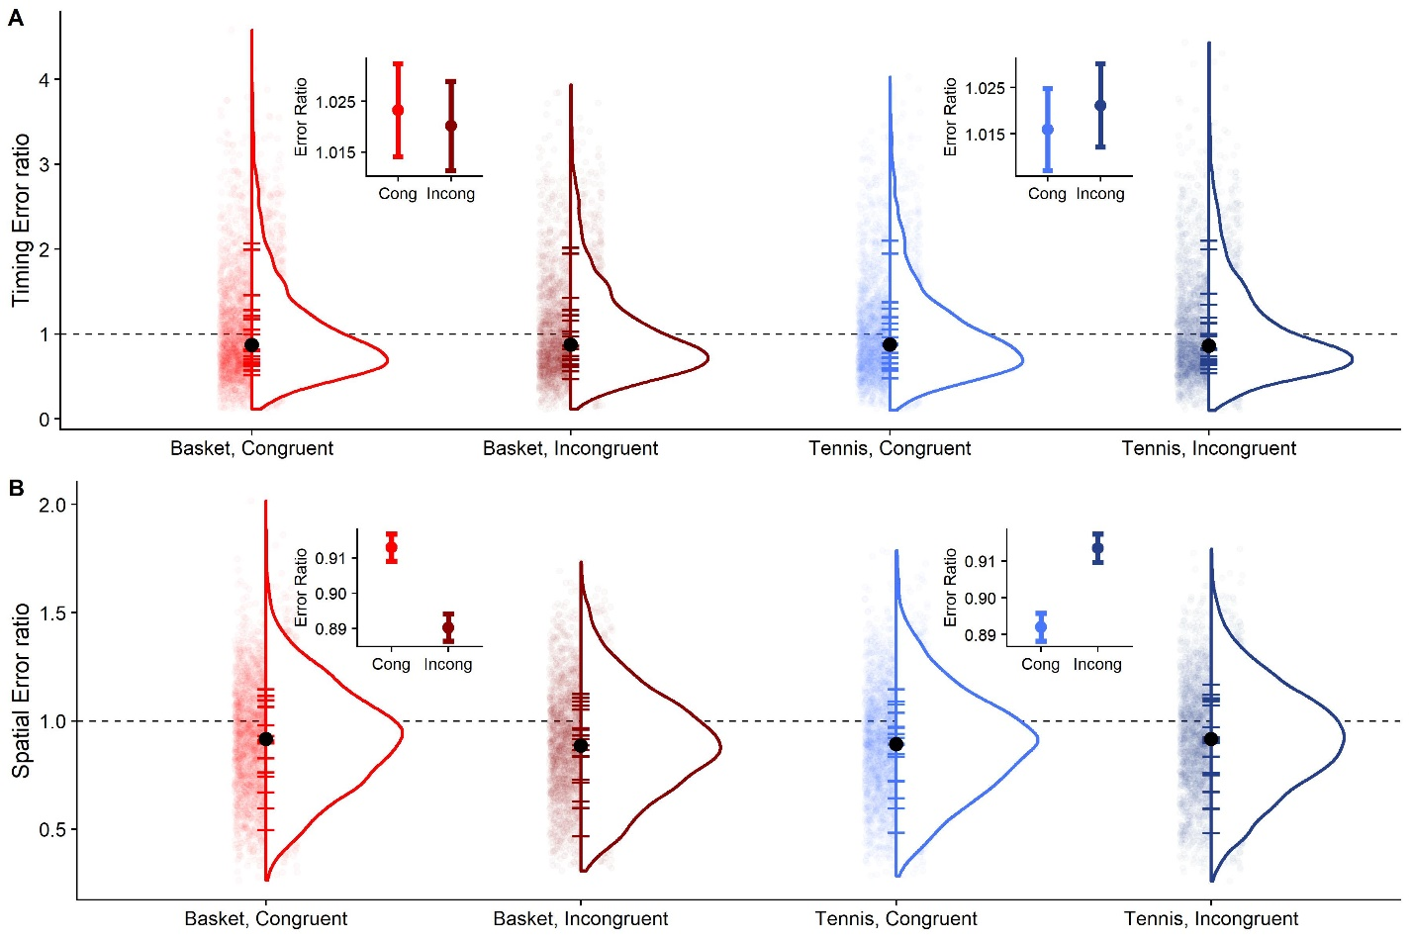

Figure : Distributions of error rations for with different combinations of size and texture. “Basket, Congruent” identifies targets with basketball size and basketball texture. “Basket, Incongruent” denotes targets with basketball size and tennis ball texture. “Tennis, Congruent” indicates targets with tennis ball size and tennis ball texture, and “Tennis, Incongruent” refers to targets with tennis ball size and basketball texture. Each small transparent dot represents the error ratio of one trial and participant. The fat black dot is the median across all conditions and participant. The short solid horizontal lines represent the median performance for each participant. The dotted line indicates a timing error ratio of 1, that is perfect accuracy. In the insets, we display the mean error of each condition (dots); the error bars indicate +/- 1 standard error. **A**. Timing task. **B**. Spatial task.

# Discussion

This study set out to study whether air drag is among the physical properties humans represent about the world. Our study supports this hypothesis to some extent: our data support strongly the hypothesis that humans do not switch between an air drag and no air drag model according to the motion they observed. Anecdotally, our participants did not consciously notice any difference between “Air Drag: Present” and “Air Drag: Absent” trials. While differences between trajectories simulated under air drag and trajectories simulated without drag are quite small, humans have, in principle, sufficient cues available to judge at least slightly above chance whether a certain trajectory is simulated under air drag. That our participants did not switch between models, is, however, in line with what has been observed with regards to other representations of world physics. While there is ample evidence that humans rely on a gravity representation for many interception tasks (Jörges & López-Moliner, 2017; Zago, McIntyre, Senot, & Lacquaniti, 2008, 2009), we also know that they perform quite badly when they have to make conscious judgments about visually perceived gravities (Jörges, Hagenfeld, & López-Moliner, 2018). Furthermore, humans rely on gravity-based estimates for interception even when this is disadvantageous and leads to biases (McIntyre et al., 2003; Zago et al., 2004a), and even after extensive training (Zago et al., 2004b).

While our data provide compelling evidence that humans use either an air drag-based model or an air drag-independent model rather than switching between both, our conclusions are less clear which of the two models humans use. While our timing task provides no evidence for a higher accuracy in either of the two conditions, there is moderate-to-strong evidence that behavior in the spatial task is more accurate for the “Air Drag: Present” condition. How can we make sense of this discrepancy between the temporal and the spatial domains? Air resistance is a force acting opposite to the velocity vector of the ball. As such, it impacts the timing and the spatial task different. With regards to the vertical velocity component, which is responsible for the time-to-contact, the effect of the air resistance has a negative sign during the first part of the trajectory; however, during the second part of the trajectory the air resistance has a positive sign. Thus, even if the total balance of the effect is negative, the total effect on the vertical speed is compensated between both parts of the trajectory being too low to be effectively perceived. But what about horizontal speed? In addition to a reduced flight time, the horizontal velocity is consistently affected negatively by air resistance throughout the trajectory. Therefore, the effect in the spatial domain is amplified (Brancazio, 1985). Overall, the spatial task thus provides the more sensitive test for Hypothesis 1.

Regarding Hypothesis 2, we could not find evidence that our participants took the different object sizes into account to extrapolate motion accordingly. While responses were equally accurate for both small and large targets in the timing task, which could lend some support to our hypothesis, the temporal differences between trajectories were too small to expect large effects. In the spatial task, where differences are more pronounce, we did find an overshoot for larger targets with regards to smaller targets. This overshoot was about half the physical mean differences in the displayed motion, indicating that participants may have used the same air drag model for both target sizes instead of switching between size-appropriate models for each. Since Hypothesis 2 was not supported by the data, it was quite unlikely to find any evidence for Hypothesis 3, and our analysis confirmed, indeed, that there was no interaction between ball size and texture.

It has to be noted that, especially in virtual reality, it is hard to eliminate biases introduced by the not quite ecological mode of presentation. For example, it has been observed that distances are often underestimated in virtual reality (Messing & Durgin, 2005). However, gravity has been suggested to serve as a mediator between space and time perception (Lacquaniti et al., 2015). Since the stimuli in our experiment were governed by a gravitational motion profile, virtual reality biases should thus be reduced with respect to stimuli that behave not according to earth gravity (Jokisch & Troje, 2003; Lacquaniti et al., 2015; Vallortigara & Regolin, 2007). And in fact, we have observed a near perfect accuracy for 1g trajectories in a previous experiment with a very similar setup (Jörges & López-Moliner, 2019). The temporal responses in this experiment are highly accurate; however, there is a consistent undershoot for the spatial responses by about 10% of the extrapolated distances. It stands to reason that the well-known underestimation of depth compression plays some role in this bias: If participants perceive the targets to be closer than they actually are, the same visual angle between target and table corresponds to a lower physical distance, both vertically and horizontally. While the same bias could lead to a misperception of the observed velocities, this should cancel out with biases of estimated distance. However, the gravity component of the motion should be more robust. A smaller physical distance paired with the same gravity value would thus lead to the object being perceived to return faster to its initial height than it actually does, leading to an undershoot in the spatial responses. However, this would also lead to a temporal underestimation of the time-to-contact, and too early responses in the timing task, which we do not observe in our data.

# Conclusions, Limitations & Future Research

In this paper, we set up to investigate whether the human brain represents air drag like other physical properties of our environment. We found evidence that lends some support to this idea. Furthermore, we hypothesized that humans might adapt their air drag-related expectations according to the physical properties of the target. We found no evidence to support this claim.

The most important limitation of our study is certainly that we did not manage to eliminate all possibly virtual reality-related biases in participant responses. The test of our first hypothesis, namely that humans rely on an internal representation of air drag, depended strongly on the response distributions of either “Air Drag: Present” or “Air Drag: Absent” trials being centered around perfect accuracy. This is the case for the timing task, but effects are not easily detectable in this condition. For the spatial task, this condition was given marginally. Therefore, the present results support our first hypothesis only to a moderate extent. A further limitation is certainly that we did not find effects of target size, i.e., participants seemed to expect the same air drag forces regardless of the size of the target. We can not say with certainty whether this occurs equally in real life or is an artifact of presentation in virtual reality. Finally, the failure to demonstrate an effect of target size precluded us from duly testing Hypothesis 3 about the interplay of prior knowledge of the object and online visual information about its size.

Future research on the representation of air drag should focus on even more ecologically valid stimuli, with the intent of eliminating biases introduced by presentation in virtual reality. High precision recordings of highly controlled real-world catching, especially with a partially occluded trajectory, are one possibility: If humans perform accurately in a reliable fashion, this would represent very strong evidence that we do indeed use an internal representation of air drag or air drag prior.

## Author Contributions

BA, BJ and JLM conceptualized the study in a joined effort. BA programmed the stimuli and tested participants. BA and BJ analyzed the results together. BJ wrote the manuscript with input from BA and JLM. JLM provided guidance at every step of the project.

## Acknowledgements

BA was supported by the fellowship FPU17/01248 from Ministerio de Educación y Formación Profesional of the Spanish government. BJ was funded by the Canadian Space Agency (CSA).

## References

Adams, W. J., Graf, E. W., & Ernst, M. O. (2004). Experience can change the “light-from-above” prior. *Nature Neuroscience*, *7*(10), 1057–1058. https://doi.org/10.1038/nn1312

Bates, D., Mächler, M., Bolker, B. M., & Walker, S. C. (2015). Fitting linear mixed-effects models using lme4. *Journal of Statistical Software*, *67*(1). https://doi.org/10.18637/jss.v067.i01

Bosco, G., Delle Monache, S., Gravano, S., Indovina, I., La Scaleia, B., Maffei, V., … Lacquaniti, F. (2015). Filling gaps in visual motion for target capture. *Frontiers in Integrative Neuroscience*, *9*. https://doi.org/10.3389/fnint.2015.00013

Brancazio, P. J. (1985). Looking into Chapman’s homer : The physics of judging a fly ball. *American Journal of Physics*, *849*(53). https://doi.org/10.1119/1.14350

Bürkner, P. C. (2018). Advanced Bayesian multilevel modeling with the R package brms. *R Journal*, *10*(1), 395–411. https://doi.org/10.32614/rj-2018-017

Chadwick, S. G., & Haake, S. J. (2000). The drag coefficient of tennis balls. *Proceedings of the 3rd International Confernce on the Engineering of Sport*, (January 2000), 169–176.

Gómez, J., & López-Moliner, J. (2013). Synergies between optical and physical variables in intercepting parabolic targets. *Frontiers in Behavioral Neuroscience*, *7*(May), 46. https://doi.org/10.3389/fnbeh.2013.00046

Hosking, S. G., & Crassini, B. (2010). The effects of familiar size and object trajectories on time-to-contact judgements. *Experimental Brain Research*, *203*(3), 541–552. https://doi.org/10.1007/s00221-010-2258-7

Indovina, I., Maffei, V., Bosco, G., Zago, M., Macaluso, E., & Lacquaniti, F. (2005). Representation of visual gravitational motion in the human vestibular cortex. *Science (New York, N.Y.)*, *308*(April), 416–419. https://doi.org/10.1126/science.1107961

Jokisch, D., & Troje, N. F. (2003). Biological motion as a cue for the perception of size. *Journal of Vision*, *3*(4), 252–264. https://doi.org/10.1167/3.4.1

Jörges, B., & López-Moliner, J. (2019). Earth-Gravity Congruent Motion Facilitates Ocular Control for Pursuit of Parabolic Trajectories. *Scientific Reports*, *9*(1). https://doi.org/10.1038/s41598-019-50512-6

Jörges, B., Hagenfeld, L., & López-Moliner, J. (2018). The use of visual cues in gravity judgements on parabolic motion. *Vision Research*, *149*, 47–58. https://doi.org/10.1016/J.VISRES.2018.06.002

Jörges, B., & López-Moliner, J. (2017). Gravity as a strong prior: Implications for perception and action. *Frontiers in Human Neuroscience*, Vol. 11. https://doi.org/10.3389/fnhum.2017.00203

Jörges, B., & López-Moliner, J. (2020). Characterizing the Strong Earth Gravity Prior. *PsyArXive*, 1–19. https://doi.org/10.31234/osf.io/exp93

La Scaleia, B., Zago, M., Moscatelli, A., Lacquaniti, F., & Viviani, P. (2014). Implied dynamics biases the visual perception of velocity. *PLoS ONE*, *9*(3). https://doi.org/10.1371/journal.pone.0093020

Lacquaniti, F., Bosco, G., Gravano, S., Indovina, I., La Scaleia, B., Maffei, V., & Zago, M. (2015). Gravity in the Brain as a Reference for Space and Time Perception. *Multisensory Research*, *28*(5–6), 397–426. https://doi.org/10.1163/22134808-00002471

Lacquaniti, F., Bosco, G., Indovina, I., La Scaleia, B., Maffei, V., Moscatelli, A., & Zago, M. (2013). Visual gravitational motion and the vestibular system in humans. *Frontiers in Integrative Neuroscience*, *7*(December), 101. https://doi.org/10.3389/fnint.2013.00101

López-Moliner, J., Field, D. T., & Wann, J. P. (2007). Interceptive timing: prior knowledge matters. *Journal of Vision*, *7*, 1–8. https://doi.org/10.1167/7.13.11

McIntyre, J., Zago, M., & Berthoz, A. (2001). Does the Brain Model Newton’s Laws. *Nature Neuroscience*, *12*(17), 109–110. https://doi.org/10.1097/00001756-200112040-00004

McIntyre, J., Zago, M., Berthoz, A., & Lacquaniti, F. (2003). The Brain as a Predictor: On Catching Flying Balls in Zero-G. In J. C. Buckey & J. L. Homick (Eds.), *The Neurolab Spacelab Mission: Neuroscience Research in Space* (pp. 55–61). National Aeronautics and Space Administration, Lyndon B. Johnson Space Center.

Messing, R., & Durgin, F. H. (2005). Distance Perception and the Visual Horizon in Head-Mounted Displays. *ACM Transactions on Applied Perception*, *2*(3), 234–250. https://doi.org/10.1145/1077399.1077403

Mijatovic, A., La Scaleia, B., Mercuri, N., Lacquaniti, F., & Zago, M. (2014). Familiar trajectories facilitate the interpretation of physical forces when intercepting a moving target. *Experimental Brain Research*, *232*(12), 3803–3811. https://doi.org/10.1007/s00221-014-4050-6

Neupärtl, N., Tatai, F., & Rothkopf, C. A. (2020). Intuitive physical reasoning about objects ’ masses transfers to a visuomotor decision task consistent with Newtonian physics Author summary. *BioRxiv*, 1–32.

Okubo, H., & Hubbard, M. (2010). Identification of basketball parameters for a simulation model. *Procedia Engineering*, *2*(2), 3281–3286. https://doi.org/10.1016/j.proeng.2010.04.145

Peters, M. A. K., Ma, W. J., & Shams, L. (2016). The Size-Weight Illusion is not anti-Bayesian after all: a unifying Bayesian account. *PeerJ*, *4*, e2124. https://doi.org/10.7717/peerj.2124

R Core Team. (2017). *A Language and Environment for Statistical Computing. R Foundation for Statistical Computing,*. Retrieved from http://www.r-project.org/.

Senot, P., Zago, M., Lacquaniti, F., & McIntyre, J. (2005). Anticipating the Effects of Gravity When Intercepting Moving Objects: Differentiating Up and Down Based on Nonvisual Cues. *Journal of Neurophysiology*, *94*(6), 4471–4480. https://doi.org/10.1152/jn.00527.2005

Senot, P., Zago, M., Le Seac’h, a., Zaoui, M., Berthoz, a., Lacquaniti, F., & McIntyre, J. (2012). When Up Is Down in 0g: How Gravity Sensing Affects the Timing of Interceptive Actions. *Journal of Neuroscience*, *32*(6), 1969–1973. https://doi.org/10.1523/JNEUROSCI.3886-11.2012

Stan Development Team. (2016). *Stan: the R interface to Stan. R package version 2.14.1*. 1–23. Retrieved from http://mc-stan.org

Vallortigara, G., & Regolin, L. (2007). Gravity bias in the interpretation of biological motion by inexperienced chicks. *Current Biology*, *16*(September), R279–R280.

Wilson, A. D., & Golonka, S. (2013). Embodied Cognition is Not What you Think it is. *Frontiers in Psychology*, *4*(February), 1–13. https://doi.org/10.3389/fpsyg.2013.00058

Zago, M., Bosco, G., Maffei, V., Iosa, M., Ivanenko, Y., & Lacquaniti, F. (2004a). Internal Models of Target Motion: Expected Dynamics Overrides Measured Kinematics in Timing Manual Interceptions. *Journal of Neurophysiology*, *91*(4), 1620–1634. https://doi.org/10.1152/jn.00862.2003

Zago, M., Bosco, G., Maffei, V., Iosa, M., Ivanenko, Y. P., & Lacquaniti, F. (2004b). Fast Adaptation of the Internal Model of Gravity for Manual Interceptions: Evidence for Event-Dependent Learning. *Journal of Neurophysiology*, *93*(2), 1055–1068. https://doi.org/10.1152/jn.00833.2004

Zago, M., La Scaleia, B., Miller, W. L., & Lacquaniti, F. (2011). Coherence of structural visual cues and pictorial gravity paves the way for interceptive actions. *Journal of Vision*, *11*(10), 1–10. https://doi.org/10.1167/11.10.13.Introduction

Zago, M., McIntyre, J., Senot, P., & Lacquaniti, F. (2008). Internal models and prediction of visual gravitational motion. *Vision Research*, *48*(14), 1532–1538. https://doi.org/10.1016/j.visres.2008.04.005

Zago, M., McIntyre, J., Senot, P., & Lacquaniti, F. (2009). Visuo-motor coordination and internal models for object interception. *Experimental Brain Research*, *192*, 571–604. https://doi.org/10.1007/s00221-008-1691-3

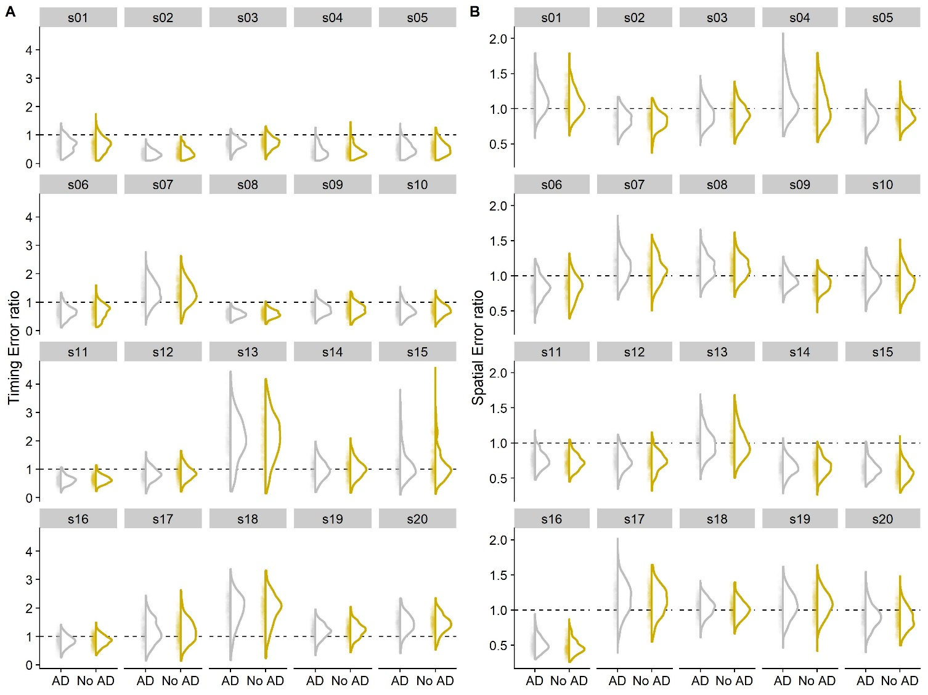

Complementary Figure : Response distributions for the Timing Error Ratio (A) and the Spatial Error Ratio (B) for each participant (different subpanels). The intermittent grey line denotes perfect accuracy. S02 and s04 were removed from analysis because of their atypical timing error distribution.